Carve-In on the Chippewa
2nd Annual – Wood Carving Event
September 16, 2023, 10:00 – 4:00
New Location
Brickhouse Pub and Banquet Room
2233 Birch St, Eau Claire, WI
(This location has 6 stairs to enter the banquet hall.)
FREE Admission - Demonstrations
Door Prizes
Used Tools/Books for Sale!
Open to the public!!
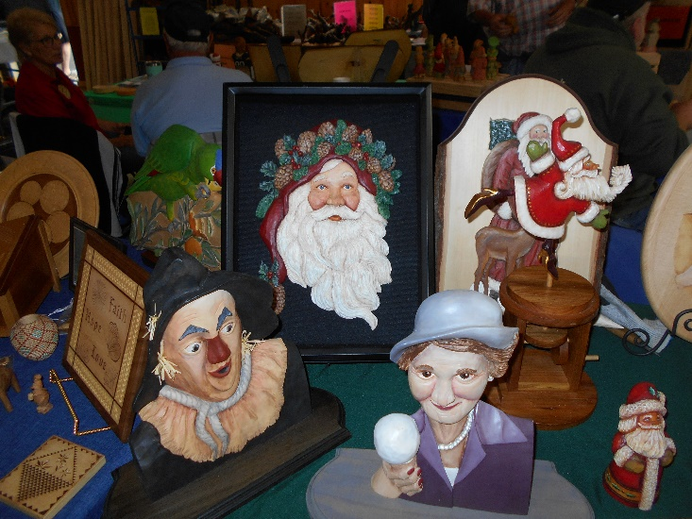
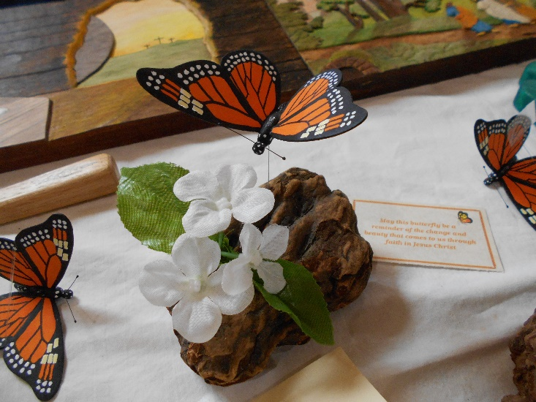

If interested in a table, contact Charlene at (715) 497-6296
Sponsored by the West Wisconsin Wood Carvers Guild
Come and learn about wood carving!

